“Design and Development of an Integrated Tourism Platform for Flights, Trains, Hotels, and Hidden Destinations”
A Project Report Submitted in the partial fulfillment of the requirements for the award of the degree of

BACHELOR OF TECHNOLOGY
In

DEPARTMENT OF COMPUTER SCIENCE ENGINEERING
&
DEPARTMENT OF COMPUTER SCIENCE AND INFORMATION TECHNOLOGY
By

R.JAGADEESH 2520090030
D.VIGNESH KUMAR 2520090071

Under the Esteemed Guidance of

Dr. Ramya Krishna
Assistant Professor
Department of Computer Science and Engineering




K L (Deemed to be) University DEPARTMENT OF COMPUTER SCIENCE ENGINEERING
&

DEPARTMENT OF COMPUTER SCIENCE AND INFORMATION TECHNOL

Declaration

The Project Report entitled “Student Smart ID Card Generator” is a record of Bonafide work of R.JAGADEESH - 2520090030 , D.VIGNESH KUMAR - 2520090071 submitted in partial fulfillment for the award of B. Tech in Computer Science and Engineering (or) Computer Science and Information Technology to the K L University. The results embodied in this report have not been copied from any other departments/University/Institute.

R.JAGADEESH – 2520090030 D.VIGNESH KUMAR – 2520090071
K L (Deemed to be) University

DEPARTMENT OF COMPUTER SCIENCE ENGINEERING

&

DEPARTMENT OF COMPUTER SCIENCE AND INFORMATION TECHNOLOGY

CERTIFICATE

This is certify that the mini project based report entitled“Student Smart ID Card Generator” is a bonafide work done and submitted by R.JAGADEESH - 2520090030 , D.VIGNESH KUMAR - 2520090071 in partial fulfillment of the requirements for the award of the degree of BACHELOR OF TECHNOLOGY in Department of Computer Science Engineering, K L (Deemed to be University), during the academic year 2025-2026.

Signature of the Guide

Signature of the Course Coordinator Signature of the HOD
ACKNOWLEDGEMENT
The success in this project would not have been possible but for the timely help and guidance rendered by many people. Our wish to express my sincere thanks to all those who has assisted us in one way or the other for the completion of my project.

Our greatest appreciation to my Course Coordinator Dr K.Madhavi, and my guide Dr Ramya Krishna, Department of Computer Science which cannot be expressed in words for his/her tremendous support, encouragement and guidance for this project.

We express our gratitude to Dr. N.Chaitanya Kumar(FED), Head of the Department for Computer Science Engineering/ Department for Computer Science and Information Technology for providing us with adequate facilities, ways and means by which we are able to complete this project-based Lab.

We thank all the members of teaching and non-teaching staff members, and also who have assisted me directly or indirectly for successful completion of this project. Finally, I sincerely thank my parents, friends and classmates for their kind help and cooperation during my work.

R.JAGADEESH - 2520090030 , D.VIGNESH KUMAR - 2520090071

Abstract

The Student ID Card Generator is a software application designed to automate the process of creating student identification cards efficiently and accurately. In educational institutions, generating ID cards manually can be time-consuming and prone to errors. This project aims to simplify and streamline the entire process by providing a user-friendly system that collects student details such as name, roll number, course, photograph, and contact information, and generates a professional ID card instantly.

A key feature of this system is the integration of QR code technology. Each generated ID card contains a unique QR code that stores or links to the student’s digital profile. When the QR code is scanned using a mobile device, it displays the student’s soft copy of the ID card or detailed information in digital format. This enhances security, enables quick verification, and reduces the need for physical documents.

This project is developed using web technologies such as HTML, CSS, and JavaScript (or any backend like Python/Java if used), ensuring ease of access and scalability. The system reduces manual effort, improves accuracy, and saves time, making it a practical solution for schools and colleges. Built using modern web technologies such as HTML5, CSS3, JavaScript, React.js, and optionally Node.js with MySQL, the application ensures responsiveness, performance, and maintainability. The project demonstrates practical implementation of frontend frameworks, API integration, and state management
Index

S.  No. | Chapters | Topics | Page.no
 |  | Acknowledgement
 |  | Abstract
1 | Introduction | - Background of the project  - Problem statement  - Scope of the project  - Objective(s)  - Importance of the application  - Target users/audience | 5-15
2 | System Requirements | - Hardware requirements  - Software requirements  - Development tools and frameworks | 16-21
3 | Technology Stack | - Front-end (e.g., React.js, Angular, HTML/CSS)  - Back-end (e.g., Node.js, Django, Spring Boot)  - Database (e.g., MongoDB, MySQL, PostgreSQL)  - Version Control (e.g., Git, GitHub)  - APIs or External services (e.g., Firebase, Stripe) | 22-32
4 | System Architecture | - High-level architecture diagram  - Description of each layer (frontend, backend, database)  - Deployment architecture (e.g., cloud, local, CI/CD  pipelines) | 33-36
5 | Design | 5.2 ER Diagram / Database schema | 37
6 | Implementation | - Module-wise implementation  - Front-end logic (UI rendering, state management)  - API integration  - Authentication & Authorization | 38-47
7 | Features | - List of main features  - How each feature works (user perspective + technical description) | 48-55
8 | Testing | - Postman testing (frontend/backend)  - Integration testing  - Tools used for testing  - Test cases and results | 56-64
9 | Deployment | - Steps to deploy  - Environment configuration  - Hosting of frontend and backend | 65-73
10 | Challenges & Limitations | - Issues faced during development  - Solutions applied  - Current limitations or known bugs | 74-82
11 | Future Enhancements | - Planned features  - Possible integrations or optimizations | 83-88
12 | Conclusion | - Summary of the project  - What was achieved  - Skills learned during development | 89-97
13 | References | - Books, tutorials, APIs, documentation sites used | 98-99

14 | Appendices | - Screenshots of the app  - Sample code snippets  - Installation/setup instructions  - User manual or guide  -Geo Tag photos with guide  -Review forms with guide signatures | 100-105

CHAPTER -1 INTRODUCTION

Background of the Project

The Student ID Card Generator project was developed to simplify and automate the process of creating student identification cards in educational institutions. Traditionally, student ID cards are prepared manually, which requires significant time and effort from administrative staff. Manual methods may also lead to data entry errors, inconsistencies, and delays in issuing ID cards to students. This project aims to overcome these challenges by providing a digital solution for generating student ID cards efficiently.
With the increasing adoption of web technologies in educational environments, there is a growing need for systems that can manage student information in a secure and user-friendly manner. The Student ID Card Generator allows students to register, log in, and enter their personal details through an intuitive web interface. Once the required information is submitted, the system automatically generates a professional-looking ID card containing all essential student details.
The project is designed using modern front-end technologies and follows a component-based architecture to ensure maintainability and scalability. Features such as responsive layouts, form validation, secure authentication, and dynamic data rendering enhance the overall user experience. The generated ID card includes important information such as student name, ID number, contact details, blood group, campus information, photograph, and validity period.
Another important aspect of the project is the Admin Dashboard. Administrators can monitor registered students, track the number of ID cards generated, and identify students who have not yet completed the ID card generation process. This functionality helps institutions maintain accurate records and improve administrative efficiency.
The system also provides the capability to download the generated ID card as a digital copy. Students can save and access their ID cards whenever required without depending on physical documents. The inclusion of QR codes further enhances verification and accessibility, making the ID cards more secure and practical for institutional use.

Overall, the Student ID Card Generator project demonstrates how web-based applications can streamline administrative tasks in educational institutions. By automating ID card creation, reducing manual work, improving data accuracy, and providing easy access to student identification information, the system contributes to a more efficient and modern campus management process.

Problem Statement

Educational institutions often face difficulties in managing and issuing student identification cards through traditional manual processes. The collection, verification, and formatting of student information require significant administrative effort and are prone to human errors. These issues can result in delays, inaccurate data, and increased operational costs for institutions.
In many colleges and universities, students must submit their details through paper forms or multiple administrative procedures before receiving an ID card. This process is time-consuming and can lead to duplication of records, missing information, and inconsistencies in the generated ID cards. Managing large numbers of student records manually becomes increasingly challenging as the student population grows.
Another major problem is the lack of a centralized system to monitor the status of ID card generation. Administrators often find it difficult to track which students have completed the registration process and which students are still pending. Without proper monitoring tools, maintaining accurate records and ensuring timely card issuance becomes a complex task.
Students also face inconvenience when they need replacement copies of their ID cards. Traditional systems usually require physical visits to administrative offices, resulting in unnecessary delays and additional workload for staff members. The absence of digital storage and downloadable ID cards further limits accessibility and flexibility.
Security and verification are additional concerns in manual ID card management systems. Without proper validation mechanisms, there is a higher risk of incorrect information being printed on ID cards. Furthermore, institutions may lack efficient methods for verifying student identities quickly during campus activities and administrative procedures.
Therefore, there is a need for a secure, automated, and user-friendly Student ID Card Generator system that allows students to register and generate ID cards digitally while enabling administrators to monitor and manage student records effectively. The proposed system aims to reduce manual effort, improve data accuracy, enhance security, and provide a streamlined solution for student identification card management.

Scope of the Project

The scope of the Student ID Card Generator project is to provide a web-based platform that enables students to create and manage their identification cards digitally. The system allows students to register, log in securely, enter their personal and academic information, upload a photograph, and generate a professional student ID card without requiring manual intervention from administrative staff.
The project covers the automation of student data collection and ID card generation processes. It includes features such as user authentication, form validation, profile photo upload, and automatic creation of ID cards containing essential student details such as name, student ID, contact information, blood group, campus details, and validity period. These features help ensure accuracy and consistency in the generated ID cards.
Another important aspect within the scope of the project is the provision of downloadable digital ID cards. Once an ID card is generated, students can save and download a soft copy for future use. This reduces dependency on physical cards and provides students with convenient access to their identification information whenever needed.
The project also includes an administrative module that enables administrators to monitor student registrations and track ID card generation activities. Through the admin dashboard, administrators can view the total number of registered students, identify students who have successfully generated their ID cards, and monitor pending records. This improves administrative control and record management.
The system is designed with a modern, responsive, and user-friendly interface that can be accessed through web browsers on various devices. The project focuses on providing an efficient and secure user experience while maintaining data integrity and reducing the complexity associated with traditional ID card management systems.
Although the current implementation is intended for educational institutions, the framework can be extended in the future to support additional functionalities such as database integration, cloud storage, email notifications, advanced security features, QR-code-based verification, and support for multiple campuses. This flexibility makes the project scalable and suitable for future enhancements according to institutional requirements.

Objectives of the Project

The primary objective of the Student ID Card Generator project is to automate the process of creating student identification cards through a web-based application. The system aims to reduce manual work and improve the efficiency of ID card generation in educational institutions.
Another objective is to provide a secure registration and authentication mechanism that allows students to create accounts, log in, and manage their personal information safely. This ensures that only authorized users can access and modify student records.
The project aims to collect, validate, and store student information accurately. By implementing form validation and structured data entry, the system minimizes errors and ensures that all required details are correctly included in the generated ID card.
A key objective is to generate professional and standardized student ID cards automatically. The generated cards include important details such as student name, student ID, photograph, contact information, blood group, campus details, and validity date, ensuring consistency across all ID cards.
The project also seeks to provide administrators with an effective monitoring system through an Admin Dashboard. This enables administrators to track registered students, monitor ID card generation status, and maintain organized records for better management and decision-making.
Finally, the project aims to enhance user convenience by allowing students to download and access digital copies of their ID cards. The system promotes a modern, paperless approach to student identification management while offering a scalable foundation for future enhancements such as QR code verification, database integration, and cloud-based storage.

Importance of the Application

The Student ID Card Generator application plays a significant role in modernizing the process of student identification management within educational institutions. By automating the creation of student ID cards, the application reduces the time and effort required by administrative staff, making the overall process faster and more efficient.
One of the major benefits of the application is its ability to improve data accuracy. Since students enter their information directly into the system and the application validates the input data, the chances of human errors, missing information, and incorrect card details are greatly reduced. This ensures that the generated ID cards are reliable and professional.
The application enhances convenience for both students and administrators. Students can register, submit their details, upload photographs, and generate their ID cards through a simple and user-friendly interface. Administrators can monitor student registrations, track card generation status, and manage records from a centralized dashboard without handling extensive paperwork.
Another important aspect of the application is its contribution to digital transformation and paperless administration. By providing downloadable digital ID cards, the system minimizes the need for repeated printing and physical document handling. This not only saves resources but also supports environmentally friendly practices within institutions.
The application also improves security and verification processes. Features such as user authentication, validated student information, and QR-code-based identification help ensure that ID cards are authentic and can be verified easily when required. This strengthens campus security and student identity management.
Furthermore, the system provides a scalable foundation for future development. Additional features such as database integration, cloud storage, notification services, biometric verification, and multi-campus support can be incorporated as institutional needs evolve. As a result, the Student ID Card Generator serves as a valuable and sustainable solution for efficient student identification management in educational institutions.

Target Users / Audience

The primary target users of the Student ID Card Generator application are students enrolled in educational institutions such as schools, colleges, and universities. Students can use the system to register their details, upload photographs, generate personalized ID cards, and download digital copies for academic and administrative purposes.
Administrative staff are another important group of users. The application helps administrators manage student records, monitor registration activities, track ID card generation status, and maintain organized databases. This reduces manual workload and improves overall administrative efficiency.
Educational institutions, including schools, colleges, universities, and training centers, can benefit from the system by adopting a standardized and automated approach to student identification management. The application helps institutions maintain accurate student records and streamline campus operations.
Faculty members and academic departments may also use the system indirectly for student verification and identification purposes. Access to accurate student information can assist in attendance management, examination processes, library services, and other academic activities.
Campus security personnel represent another target audience. The generated ID cards, especially those containing QR codes and verified student information, can be used for quick identity verification and access control within the institution, thereby improving campus security.
In the future, the application can be extended to serve additional users such as alumni, temporary staff, event participants, and visitors by generating customized identification cards. This flexibility makes the Student ID Card Generator a versatile solution suitable for a wide range of educational and organizational environments.

CHAPTER -2 SYSTEM REQUIREMENTS

Hardware Requirements

The Student ID Card Generator is a web-based application that requires standard computer hardware for development, testing, and deployment. Since the system is designed to perform tasks such as user registration, data management, image uploading, and ID card generation, it can operate efficiently on most modern computers without the need for specialized hardware components.
A computer equipped with at least an Intel Core i3 processor or its equivalent is sufficient for running the application. For smoother performance, especially during development and multitasking, an Intel Core i5 or higher processor is recommended. The processor handles application execution, data processing, and browser operations required by the system.
The application requires a minimum of 4 GB RAM to function properly. However, 8 GB RAM or more is recommended for better responsiveness and efficient handling of multiple browser tabs, development tools, and background processes. Adequate memory ensures that the system operates without performance delays.
Storage is another important hardware requirement. A minimum of 128 GB SSD or 500 GB HDD is sufficient for storing project files, source code, student records, uploaded photographs, and generated ID cards. Using an SSD is recommended because it provides faster data access and improves overall system performance.
The system requires a monitor with a minimum resolution of 1366 × 768 pixels to display the application's user interface effectively. Standard input devices such as a keyboard and mouse are necessary for entering student information, managing records, and navigating through the application's features.
A stable internet connection is also essential, particularly during development, software updates, dependency installation, and online deployment. The hardware requirements are kept affordable and accessible, allowing educational institutions of different sizes to implement the Student ID Card Generator system without significant infrastructure investments.

Software Requirements

The Student ID Card Generator application is developed using modern web technologies that support efficient user interaction, data management, and responsive design. The software requirements include the operating system, development tools, programming languages, frameworks, and web browsers necessary for the successful development and execution of the application.
A suitable operating system such as Windows 10/11, macOS, or Linux is required to develop and run the application. These operating systems provide the necessary environment for installing development tools, executing source code, and testing application functionalities. Their compatibility with modern web technologies ensures smooth project development.
The application is built using React.js, a popular JavaScript library for creating dynamic and interactive user interfaces. HTML is used for structuring web pages, CSS for styling and designing the interface, and JavaScript for implementing application logic and user interactions. These technologies work together to provide a responsive and user-friendly experience.
For coding and project management, Visual Studio Code (VS Code) is used as the primary development environment. It offers features such as syntax highlighting, debugging support, extensions, and integrated terminal access, which improve developer productivity and simplify project maintenance.
The project utilizes Node.js and npm (Node Package Manager) to manage dependencies and execute the React application. These tools are essential for installing required packages, running development servers, and building the application for deployment. Modern web browsers such as Google Chrome, Mozilla Firefox, Microsoft Edge, or Safari are required to access and test the application.
Additionally, software tools such as Git and GitHub can be used for version control and project collaboration. These tools help track code changes, manage project versions, and facilitate teamwork during development. Together, these software components provide a complete environment for developing, testing, deploying, and maintaining the Student ID Card Generator application efficiently.

Development Tools and Frameworks

The development of the Student ID Card Generator application relies on a set of modern tools and frameworks that support efficient coding, testing, and deployment. These technologies help developers build a responsive, scalable, and user-friendly web application while reducing development time and complexity.
React.js is the primary framework used in this project. It is a powerful JavaScript library for building dynamic user interfaces through reusable components. React enables efficient rendering of web pages, simplifies state management, and improves the overall performance of the application. Its component-based architecture makes the system easier to maintain and extend in the future.
Visual Studio Code (VS Code) serves as the main development environment for writing and managing the project's source code. It provides features such as code completion, syntax highlighting, debugging tools, and extension support, allowing developers to work more efficiently. The integrated terminal also simplifies project execution and dependency management.
Node.js and npm (Node Package Manager) are used to support the React development environment. Node.js provides the runtime required for executing JavaScript outside the browser, while npm manages project dependencies and libraries. These tools are essential for installing packages, running the development server, and building the final application.
HTML, CSS, and JavaScript form the foundation of the application's front-end development. HTML is used to structure web pages, CSS is responsible for styling and layout design, and JavaScript adds interactivity and functionality. Together, these technologies create an engaging and responsive user experience across different devices and screen sizes.
Additionally, Git and GitHub can be used for version control and project collaboration. Git helps track changes made to the source code, while GitHub provides a platform for storing repositories and collaborating with team members. These development tools and frameworks collectively ensure the successful design, implementation, testing, and maintenance of the Student ID Card Generator application.

CHAPTER-3 TECHNOLOGY STACK

Front-End Design

The front-end design of the Student ID Card Generator application is responsible for providing an interactive and user-friendly interface through which students and administrators can access the system. The front end acts as the communication layer between users and the application's functionality, ensuring smooth navigation and an efficient user experience. It is designed to be responsive, visually appealing, and easy to use across different devices and screen sizes.
The application is developed using React.js, a modern JavaScript library that enables the creation of reusable UI components. React's component-based architecture helps organize the application into smaller, manageable parts such as login forms, registration pages, student profile sections, ID card templates, and dashboard components. This approach improves code maintainability and simplifies future enhancements.
HTML is used to define the structure of web pages, while CSS is responsible for styling and layout design. CSS is utilized to create visually attractive forms, navigation menus, buttons, cards, and dashboards. Responsive design techniques ensure that the application adapts effectively to desktops, laptops, tablets, and mobile devices, providing a consistent user experience across platforms.
JavaScript plays a crucial role in implementing dynamic functionality within the application. It handles user interactions, form validations, data processing, and real-time updates on the interface. Through JavaScript, the application can instantly display generated ID cards, validate user inputs, and update dashboard information without requiring page reloads.
The front-end interface includes several key modules such as Student Registration, Login Authentication, Profile Management, ID Card Generation, ID Card Download, and the Admin Dashboard. Each module is designed with simplicity and usability in mind, allowing users to perform tasks efficiently with minimal technical knowledge.

Overall, the front-end design focuses on delivering a modern, responsive, and interactive experience that enhances usability and accessibility. By combining React.js, HTML, CSS, and JavaScript, the Student ID Card Generator application provides an efficient platform for managing student information and generating professional digital ID cards.

Back-End Design

The back-end design of the Student ID Card Generator application is responsible for managing data processing, user authentication, business logic, and communication between the user interface and the data storage system. It serves as the core component that ensures the smooth functioning of the application by handling requests and providing appropriate responses to users.
The application utilizes Node.js as the server-side runtime environment. Node.js enables efficient handling of multiple user requests simultaneously and provides a scalable platform for web application development. Its event-driven architecture allows the system to perform operations quickly and efficiently, ensuring a responsive user experience.
The back-end manages essential functionalities such as user registration, login authentication, student data validation, profile management, and ID card generation. Whenever a user submits information through the front-end interface, the back-end processes the request, validates the data, and stores it securely. This helps maintain data accuracy and consistency throughout the application.
For data storage, the system can be integrated with databases such as MongoDB, MySQL, or PostgreSQL. The database stores student records, login credentials, profile information, uploaded photographs, and generated ID card details. Proper database management ensures efficient retrieval, updating, and maintenance of student information whenever required.
Security is an important aspect of the back-end design. Authentication mechanisms ensure that only authorized users can access the system. Password encryption, session management, and input validation help protect user data from unauthorized access and potential security threats. These measures contribute to the reliability and trustworthiness of the application.
Overall, the back-end design provides a robust foundation for the Student ID Card Generator system. By managing data processing, authentication, database interactions, and security functions, the back-end ensures that the application operates efficiently while supporting future enhancements such as cloud storage, QR code verification, notification services, and advanced administrative features.

Database Design

The database design of the Student ID Card Generator application is responsible for storing, organizing, and managing all student-related information in a structured manner. A well-designed database ensures efficient data retrieval, secure storage, and accurate management of records required for ID card generation and administrative operations.
The primary entity in the database is the Student table, which stores essential details such as Student ID, Name, Email Address, Mobile Number, Date of Birth, Blood Group, Department, Campus, and Photograph. Each student record is assigned a unique identifier to prevent duplication and ensure accurate tracking of information throughout the system.
Another important entity is the User Authentication table, which manages login credentials for students and administrators. This table contains information such as User ID, Username, Email, Password Hash, and User Role. Authentication data is stored securely to protect user accounts and maintain system security.
The database also includes an ID Card Details table that stores information related to generated ID cards. This table contains attributes such as Card ID, Student ID, Issue Date, Expiry Date, QR Code Information, and Card Status. The relationship between the Student table and ID Card table ensures that each generated ID card is linked to the correct student record.
An Admin Management table may also be included to maintain administrator information and permissions. This enables administrators to monitor student registrations, manage records, track ID card generation activities, and perform other administrative functions efficiently through the dashboard.
Overall, the database design provides a reliable and scalable foundation for the Student ID Card Generator application. By maintaining structured relationships between students, authentication records, administrators, and ID card information, the database supports efficient data management, enhances security, and facilitates future system expansion and feature integration.

Version Control

Version control plays an important role in the development of the Student ID Card Generator application by helping developers manage changes made to the source code throughout the project lifecycle. It enables efficient tracking of modifications, collaboration among team members, and maintenance of different versions of the application. By using version control, developers can easily identify changes, restore previous versions, and maintain code quality.
The project utilizes Git as the version control system. Git is a distributed version control tool that allows developers to record changes made to files and source code. It helps maintain a complete history of project development and provides mechanisms for branching, merging, and conflict resolution. This makes the development process more organized and reliable.
GitHub is used as the remote repository platform for storing and managing the project's source code. It provides a centralized location where developers can upload, share, and collaborate on project files. GitHub also offers features such as issue tracking, pull requests, code reviews, and repository management, which improve teamwork and project coordination.
Version control helps protect the project from accidental data loss by maintaining backups of previous code versions. If an error is introduced during development, developers can easily revert to a stable version without affecting the entire application. This capability significantly reduces development risks and improves software reliability.
The use of branches allows developers to work on new features, bug fixes, or enhancements independently without affecting the main project code. Once the changes are tested and verified, they can be merged into the main branch. This approach supports structured development and ensures that only stable code is integrated into the final application.
Overall, version control provides an efficient framework for managing the development of the Student ID Card Generator application. Through Git and GitHub, the project benefits from better collaboration, secure code management, change tracking, and streamlined software maintenance, ensuring a more organized and professional development process.

APIs or External Services

The Student ID Card Generator application can utilize various APIs and external services to enhance its functionality, improve user experience, and support future scalability. APIs (Application Programming Interfaces) enable communication between different software systems, allowing the application to access additional features and services without developing them from scratch.
One of the key external services that can be integrated into the application is a QR Code Generation API. This service automatically generates unique QR codes for each student ID card. The QR code can store student identification information and can be scanned for quick verification during campus entry, examinations, library access, and other institutional activities.
The application may also integrate Cloud Storage Services such as Google Drive, Firebase Storage, or Amazon S3. These services allow student photographs and generated ID cards to be stored securely in the cloud. Cloud storage improves data accessibility, backup management, and scalability while reducing the burden on local storage systems.
For user authentication and account management, services such as Firebase Authentication can be incorporated. These services provide secure login mechanisms, password management, email verification, and user session handling. By utilizing established authentication services, the application can enhance security and reduce the complexity of implementing authentication features manually.
Email service providers such as EmailJS, Gmail SMTP, or SendGrid can be integrated to send notifications and confirmations to students. These notifications may include account registration confirmations, password reset links, ID card generation updates, and other important communications between the institution and students.
The application can also make use of PDF Generation Libraries and Services to allow users to download their generated ID cards in PDF format. This feature ensures that students have a portable and printable version of their identification card that can be accessed whenever required.For future enhancements, the system may integrate Database-as-a-Service (DBaaS) platforms such as MongoDB Atlas or Firebase Firestore. These services provide managed database solutions with automatic backups, high availability, and secure data storage. Such integrations can improve system performance and simplify database administration.
Overall, APIs and external services play a vital role in extending the capabilities of the Student ID Card Generator application. By integrating QR code services, cloud storage, authentication systems, email services, PDF generation tools, and cloud databases, the application becomes more secure, scalable, efficient, and capable of meeting the evolving needs of educational institutions.

CHAPTER -4 SYSTEM ARCHITECTURE

High-level architecture diagram
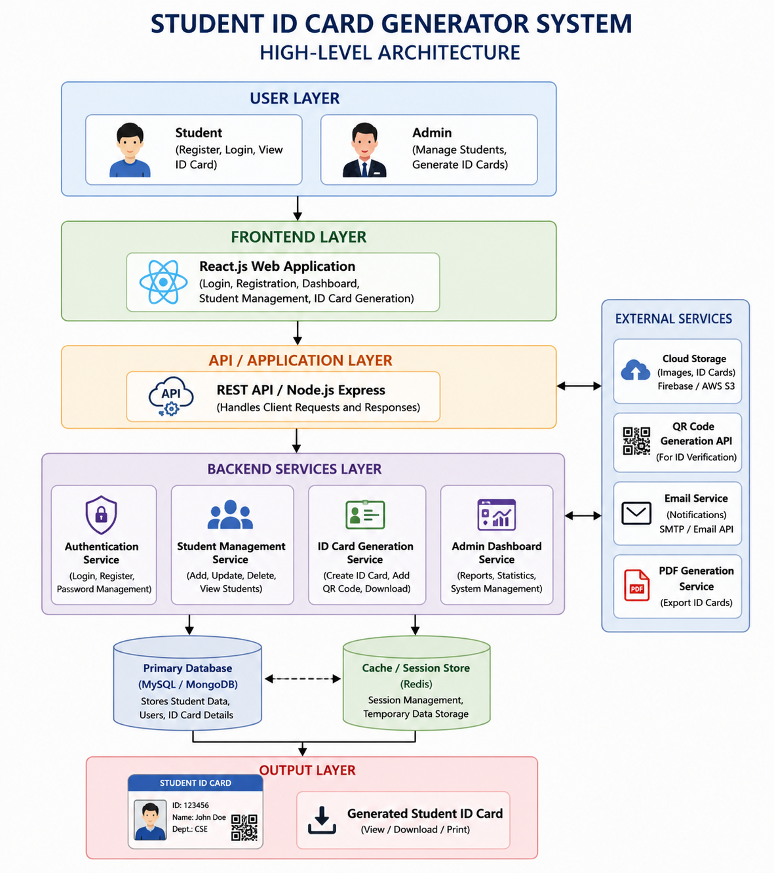

Description of Each Layer (Frontend, Backend, Database)

The Frontend Layer serves as the user interface of the Student ID Card Generator system. It is developed using React.js and enables students and administrators to interact with the application through web browsers. This layer provides features such as user registration, login, student information forms, ID card preview, ID card download, and the admin dashboard. It focuses on delivering a responsive, attractive, and user-friendly experience while ensuring smooth navigation between different modules.
The frontend is responsible for collecting user inputs, validating form data, displaying student information, and presenting generated ID cards. It communicates with the backend through REST APIs and displays the responses received from the server. By using reusable React components, the frontend remains scalable, maintainable, and easy to update with new features.
The Backend Layer acts as the core processing unit of the application. It is developed using Node.js and Express.js and handles all business logic, user authentication, data processing, and communication between the frontend and the database. When users submit registration details, login credentials, or requests for ID card generation, the backend processes these requests and returns appropriate responses.
This layer includes multiple services such as Authentication Service, Student Management Service, ID Card Generation Service, and Admin Dashboard Service. It ensures data validation, manages user sessions, generates QR codes, and controls access permissions. The backend also integrates with external services such as cloud storage, email services, and PDF generation tools to enhance system functionality and security.
The Database Layer is responsible for storing and managing all information related to students, administrators, authentication records, and generated ID cards. Databases such as MySQL or MongoDB can be used to store structured data efficiently and securely. This layer ensures data consistency, integrity, and availability throughout the system.
Student details such as name, student ID, email address, phone number, blood group, campus information, uploaded photographs, and ID card status are maintained within the database. The database also stores login credentials, QR code information, and administrative records. By organizing data into well-defined tables or collections, the system can quickly retrieve, update, and manage information whenever required.
The Database Layer works closely with the backend services to provide reliable data access and storage operations. Proper indexing, backup mechanisms, and security measures help protect sensitive student information while ensuring high performance. This layer forms the foundation of the Student ID Card Generator system and supports future scalability and feature expansion.

Deployment Architecture (Cloud, Local, CI/CD Pipelines)

The deployment architecture of the Student ID Card Generator system defines how the application is developed, tested, deployed, and maintained in different environments. The system is designed to support both local deployment for development purposes and cloud deployment for production use. This flexible architecture ensures accessibility, scalability, and efficient management of application resources.
During development and testing, the application can be deployed on a local machine. The React.js frontend runs on a local development server, while the Node.js/Express backend processes user requests and manages application logic. The database, such as MongoDB or MySQL, is installed locally and stores student records, authentication details, and ID card information. This setup allows developers to test features, identify bugs, and implement enhancements before releasing the application.
For production environments, the application can be deployed on cloud platforms such as Amazon Web Services (AWS), Google Cloud Platform (GCP), Microsoft Azure, Render, Railway, or Vercel. The frontend application is hosted on a web hosting service, while the backend APIs run on cloud servers. Cloud databases store student information securely and provide high availability, automatic backups, and scalability. Cloud deployment enables users to access the system from anywhere through an internet connection.
The React.js frontend can be deployed using services such as Vercel, Netlify, or AWS Amplify. These platforms provide fast content delivery, automatic builds, and secure HTTPS support. The frontend communicates with backend APIs through secure HTTP requests, ensuring smooth interaction between users and the system.

The Node.js backend can be hosted on cloud services such as Render, Railway, AWS EC2, or Azure App Services. Databases such as MongoDB Atlas or MySQL Cloud Services store application data securely. The backend handles authentication, student management, ID card generation, and administrative functions while maintaining secure communication with the database.
Continuous Integration and Continuous Deployment (CI/CD) pipelines automate the process of building, testing, and deploying the application. Tools such as GitHub Actions, GitLab CI/CD, or Jenkins can be integrated with the project repository. Whenever developers push code changes to GitHub, the pipeline automatically performs code validation, executes tests, builds the application, and deploys the latest version to the hosting platform.
The CI/CD process reduces manual deployment effort, improves software quality, and ensures faster delivery of updates. Automated testing helps identify issues early, while continuous deployment ensures that new features and bug fixes are made available to users quickly. This approach enhances reliability and minimizes downtime during application updates.
The deployment architecture combines local development, cloud hosting, and automated CI/CD pipelines to create a reliable and scalable environment for the Student ID Card Generator system. This architecture supports efficient application management, secure data storage, continuous improvement, and future expansion as the number of users and system requirements grow.

CHAPTER -5 DESIGN

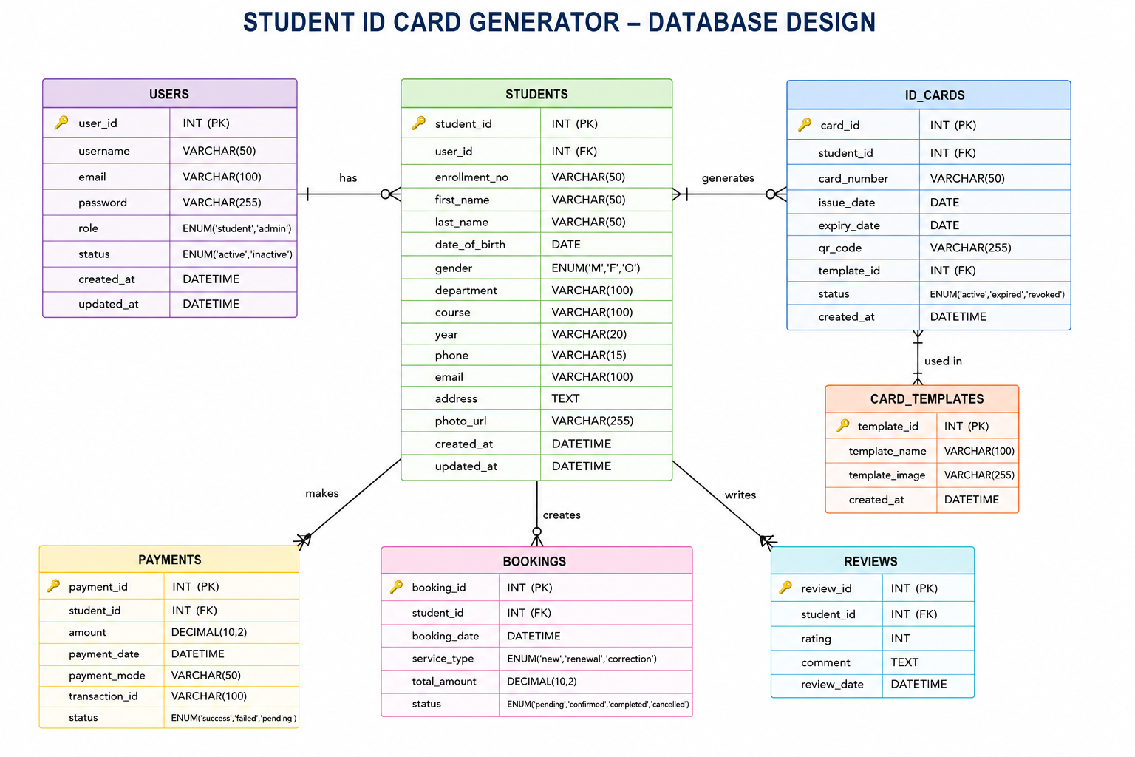

CHAPTER -6 IMPLEMENTATION

Section 6.1 – Module-Wise Implementation

The Student ID Card Generator system is implemented using a modular architecture where each module performs a specific function within the application. This approach improves maintainability, scalability, and overall system performance. The major modules implemented in the project are described below.
The User Authentication Module is responsible for managing user registration and login functionalities. Students can create accounts using their credentials and securely access the system. The module validates user information, verifies login credentials, and controls access to protected sections of the application. Administrators can also log in using authorized credentials to access the admin dashboard and monitor student activities.
This module ensures data security by preventing unauthorized access and maintaining user session management throughout the application.The Student Registration Module allows students to enter their personal and academic information required for ID card generation. Students provide details such as full name, student ID, email address, phone number, blood group, gender, campus name, campus address, and validity date.
The module performs input validation to ensure that all mandatory fields are completed correctly before the information is submitted. This helps maintain data accuracy and reduces the possibility of generating incorrect ID cards.
The Photo Upload Module enables students to upload their profile photographs, which are displayed on the generated ID card. The system accepts image files in supported formats and validates them before processing.Uploaded photographs are stored securely and linked to the corresponding student record. This module ensures that every generated ID card contains an accurate and identifiable student photograph.
The ID Card Generation Module is the core component of the application. After successful submission of student details, the module automatically creates a professional student ID card containing all required information.
The generated card includes the student's photograph, name, student ID, contact details, blood group, campus information, validity period, and QR code. The module dynamically populates card elements using the information provided by the student, ensuring consistency and accuracy.
The QR Code Generation Module generates a unique QR code for each student ID card. The QR code stores relevant identification information that can be scanned for quick verification purposes.This module enhances security and improves identity verification processes within the institution. It also supports future integration with attendance systems, library management systems, and campus access control mechanisms.
The Download and Export Module allows students to save their generated ID cards as digital copies. Once the card is generated, users can download it and store it for future use.This module provides a convenient method for accessing student identification information without requiring repeated visits to administrative offices. It also supports digital and paperless record management practices.
The Admin Dashboard Module enables administrators to monitor and manage student records effectively. Through this module, administrators can view the total number of registered students, generated ID cards, and pending records.The dashboard provides statistical information and real-time tracking of student activities. Administrators can use this information to ensure smooth operation of the ID card generation process and maintain accurate institutional records.
The Database Management Module handles the storage, retrieval, updating, and maintenance of all application data. Student information, login credentials, uploaded photographs, generated ID card details, and administrative records are securely stored in the database.This module ensures data consistency, integrity, and efficient access to information. It serves as the backbone of the application and supports all other modules by providing reliable data management services.
The User Interface Module provides a modern and responsive design that allows users to interact with the application easily. Developed using React.js, HTML, CSS, and JavaScript, the interface includes forms, dashboards, buttons, cards, and navigation components.The module focuses on usability, accessibility, and responsiveness, ensuring a smooth experience across desktops, laptops, tablets, and mobile devices. It enhances user satisfaction by providing a clean and intuitive interaction environment.
Section 6.2 – Front-End Logic (UI Rendering and State Management)

The front-end logic of the Student ID Card Generator application is responsible for managing user interactions, rendering dynamic user interfaces, and maintaining application state. The frontend is developed using React.js, which provides a component-based architecture that simplifies UI development and improves code reusability. The application dynamically updates the user interface based on user actions and changes in application data without requiring full page reloads.
UI rendering is achieved through React components that represent different sections of the application, including the Home Page, Login Page, Registration Form, Student Dashboard, ID Card Generator, Download Page, and Admin Dashboard. Each component is responsible for displaying specific information and handling user interactions. React's rendering mechanism ensures efficient updates by modifying only the affected parts of the interface whenever data changes.
State management plays a crucial role in maintaining and updating application data. React Hooks such as useState are used to store information entered by users, including student details, uploaded photographs, login credentials, and generated ID card information. Whenever users modify form fields or perform actions, the corresponding state variables are updated, and the interface automatically reflects the latest data.
The application also uses useEffect hooks to handle side effects such as data loading, authentication verification, and dashboard updates. This allows components to execute specific functions when they are first rendered or when particular state values change. As a result, the application remains synchronized with the latest information and provides a seamless user experience.
Form handling and validation are important aspects of the frontend logic. Before submitting data, the system validates mandatory fields such as student name, student ID, email address, phone number, blood group, and campus details. Validation helps prevent incomplete or incorrect information from being processed, thereby improving data accuracy and reducing potential errors during ID card generation.

Navigation between different pages is managed through React Router, which enables smooth transitions without refreshing the entire application. Users can move between registration, login, dashboard, and ID card generation pages efficiently. Conditional rendering is also implemented to display different content based on user roles, ensuring that students and administrators access only the features relevant to them.
Overall, the front-end logic combines UI rendering and state management techniques to create an interactive, responsive, and user-friendly application. Through React components, state management hooks, form validation, and dynamic rendering, the Student ID Card Generator system delivers a seamless experience while maintaining efficient performance and scalability.

6.3 API Integration

API Integration is an essential part of the Student ID Card Generator application, enabling communication between the frontend and backend components of the system. APIs (Application Programming Interfaces) act as intermediaries that allow the React.js frontend to exchange data with the Node.js backend and database. Through API integration, the application can perform operations such as user authentication, student data management, ID card generation, and administrative monitoring efficiently.
The frontend sends HTTP requests to the backend whenever users perform actions such as registration, login, updating student information, or generating an ID card. These requests are processed by RESTful APIs developed using Node.js and Express.js. The backend validates the received data, performs the required operations, and returns appropriate responses to the frontend for display.
One of the primary APIs implemented in the system is the Authentication API. This API handles user registration, login verification, password validation, and session management. It ensures that only authorized students and administrators can access protected areas of the application while maintaining data security and user privacy.
The Student Management API is responsible for managing student information. It allows the frontend to submit, retrieve, update, and manage student records stored in the database. Through this API, students can provide personal details, upload photographs, and update profile information whenever necessary.
The ID Card Generation API processes student information and generates digital ID cards dynamically. When a student submits the required details, the API retrieves the data, generates the ID card layout, creates a QR code if applicable, and prepares the card for display and download. This automation significantly reduces manual effort and improves efficiency.
The Admin Dashboard API provides statistical and management data to administrators. It retrieves information such as total registered students, generated ID cards, pending students, and other administrative metrics. These APIs help administrators monitor system activity and maintain accurate institutional records.
Overall, API integration ensures seamless communication between different layers of the Student ID Card Generator application. By connecting the frontend, backend, database, and external services, APIs enable secure data exchange, efficient processing, and smooth execution of application features. This integration forms the foundation for a responsive, scalable, and reliable student identification management system.

6.4 Authentication and Authorisation

Authentication and Authorization are critical security components of the Student ID Card Generator application. These mechanisms ensure that only legitimate users can access the system and that each user is granted permissions according to their role. By implementing proper authentication and authorization, the application protects sensitive student information and prevents unauthorized access to administrative functions.
Authentication is the process of verifying the identity of a user before granting access to the system. In the Student ID Card Generator application, users are required to register and log in using valid credentials such as a username, email address, and password. During login, the system verifies the entered credentials against the stored user records in the database. Only users with valid credentials are allowed to access the application features.
The registration process collects user information and securely stores account details in the database. Passwords are encrypted or hashed before storage to improve security and protect user data from unauthorized access. Input validation is also performed during registration to ensure that only valid and complete information is accepted by the system.
Authorization determines what actions a user can perform after successful authentication. The application implements role-based access control (RBAC), where different permissions are assigned to students and administrators. Students can register, log in, enter personal details, generate ID cards, and download their generated cards, while administrators have additional privileges to monitor registrations, view statistics, and manage student records through the admin dashboard.
Session management is used to maintain user login status throughout the application. Once authenticated, users can access authorized resources without repeatedly entering their credentials. The system monitors active sessions and restricts access to protected pages when a user is not logged in. Logout functionality is also provided to terminate sessions securely when users finish their activities.
To enhance security, the application implements measures such as password protection, input validation, secure API communication, and access restrictions. These mechanisms help prevent common security threats such as unauthorized access, credential misuse, and data manipulation. Authentication and authorization work together to ensure that student information remains confidential and that system resources are accessed only by authorized users.
Overall, the Authentication and Authorization module provides a secure framework for user management within the Student ID Card Generator application. By verifying user identities, enforcing role-based permissions, and protecting sensitive data, the system maintains security, reliability, and trust while delivering a safe environment for both students and administrators.

CHAPTER 7- FEATURES

List of Main Features

The Student ID Card Generator application is designed to simplify and automate the process of creating student identification cards. One of its primary features is user registration, which allows students to create accounts and securely store their personal and academic information. The system also provides secure login functionality for both students and administrators, ensuring that only authorized users can access application resources and perform specific tasks.
The application enables students to manage their profiles by entering and updating details such as name, student ID, email address, phone number, blood group, department, and campus information. Students can upload their photographs, which are automatically included in the generated ID cards. Input validation mechanisms ensure that all required information is entered correctly before processing, thereby improving data accuracy and reducing errors.
A key feature of the system is the automatic generation of professional student ID cards. Based on the information provided by the student, the application dynamically creates an ID card containing essential details, including the student's photograph, identification number, contact information, blood group, institution details, and validity period. The system also generates unique QR codes that can be used for identity verification and campus-related activities.
The application provides a preview feature that allows students to review their generated ID cards before downloading them. Once verified, students can download digital copies of their ID cards for future use. This functionality promotes a paperless approach and provides convenient access to identification documents without requiring repeated visits to administrative offices.
Administrators are provided with a dedicated dashboard that displays important information related to student registrations, generated ID cards, and pending records. The dashboard helps administrators monitor system activities, manage student data, and maintain accurate institutional records efficiently. Role-based access control ensures that students and administrators can only access the features relevant to their responsibilities.

The system also incorporates secure database management for storing user credentials, student information, photographs, and generated ID card data. Its responsive design allows users to access the application from desktops, laptops, tablets, and mobile devices. Furthermore, the architecture is scalable and can support future enhancements such as cloud storage integration, email notifications, biometric verification, attendance management, and multi-campus deployment, making it a comprehensive solution for modern student identification management.

How Each Feature Works

The Student ID Card Generator application starts with the user registration feature, where students create an account by entering basic information such as their name, email address, and password. The system validates the entered details and stores them securely in the database for future access.
After registration, users can log in to the system using their registered credentials. During the login process, the application verifies the entered username or email and password against the stored records. If the credentials are correct, access is granted to the application.
The authentication feature ensures that only authorized users can access the system. It prevents unauthorized access to student records and administrative functions by validating user identity before allowing entry into protected sections of the application.
Once logged in, students can access their profile section. This feature allows them to enter and manage personal information such as student ID, department, phone number, email address, blood group, date of birth, and campus details. The information entered becomes the basis for generating the ID card.
The profile management feature also allows students to edit and update their information whenever required. Any modifications made by the student are automatically reflected in future ID card generations, ensuring that records remain current and accurate.
The application provides a photo upload feature that allows students to upload their passport-size photograph. The system checks the uploaded image format and size before accepting it. Once approved, the image is stored and linked to the student's profile.
The uploaded photograph is displayed in the ID card preview section. This ensures that the generated ID card contains a visual identification element, making the card more useful for verification and security purposes.
The form validation feature continuously checks user input during data entry. Mandatory fields cannot be left empty, and incorrect formats such as invalid email addresses or phone numbers are rejected. This improves data quality and minimizes errors.
When all required information has been provided, the student can initiate the ID card generation process. The system retrieves the stored data from the database and dynamically populates a predefined ID card template with the student's details.
The ID card generation module automatically arranges information such as the student's name, photograph, student ID, department, contact details, blood group, campus name, and validity period in a professional format. This eliminates manual design efforts and ensures consistency.
A QR code is generated simultaneously with the ID card. The QR code contains unique identification information associated with the student. It can be scanned using compatible devices to quickly verify the student's identity.
The QR code feature enhances security by providing a fast and reliable verification mechanism. It can be integrated with attendance systems, library management systems, event registrations, and campus access control applications.
After generating the ID card, the application displays a preview to the student. This preview feature allows users to review all information before downloading the final version. Students can identify mistakes and make corrections if necessary.
The download functionality enables students to save the generated ID card to their devices. The card can be stored digitally and accessed whenever required. This reduces dependence on physical documents and supports paperless operations.
The application also includes an administrator login feature. Administrators use separate credentials to access the administrative dashboard and perform management-related tasks within the system.
The admin dashboard collects data from the database and presents important statistics, including the total number of registered students, generated ID cards, and pending registrations. This information helps administrators monitor system activities effectively.
Administrators can view student records through the dashboard interface. This feature allows them to verify student information, track registration status, and maintain institutional records in an organized manner.
The database management feature operates behind the scenes to store, retrieve, update, and manage all application data. Every registration, profile update, photograph upload, and ID card generation activity is recorded within the database.
The responsive user interface ensures that all features function properly across desktops, laptops, tablets, and mobile devices. Users can access the application from different platforms without experiencing significant differences in functionality or appearance.
Overall, all features of the Student ID Card Generator application work together to provide a complete digital solution for student identification management. The combination of authentication, profile management, photo upload, ID card generation, QR code integration, download capabilities, administrative monitoring, and secure data management creates an efficient, reliable, and user-friendly system for educational institutions.

CHAPTER -8 TESTING

Postman Testing (Frontend/Backend)

Postman was used to test the APIs of the Student ID Card Generator application and verify communication between the frontend and backend components. The testing process ensured that all API endpoints functioned correctly and returned the expected responses. It helped identify errors, validate data flow, and confirm that the application worked according to the specified requirements.
The User Registration API was tested by sending student information such as name, email address, password, student ID, and contact details. The API successfully validated the input data and stored it in the database. Appropriate success and error messages were returned based on the validity of the submitted information.
The Login API was tested to verify user authentication functionality. Valid credentials allowed users to access the system, while incorrect usernames or passwords generated authentication error messages. This confirmed that the login mechanism effectively restricted unauthorized access.
The Student Profile API was tested to ensure proper retrieval and updating of student records. The API successfully fetched student information from the database and updated records whenever modifications were made. This verified the correctness of profile management operations.
The Photo Upload API was tested by uploading student photographs through API requests. The backend processed image files successfully and stored them securely. Validation checks ensured that only supported image formats were accepted by the system.
The ID Card Generation and QR Code APIs were tested to confirm that student details were correctly processed and converted into digital ID cards. The APIs generated ID card information and unique QR codes associated with each student record, ensuring accurate identification and verification functionality.
The Admin Dashboard APIs were tested to retrieve information such as total registered students, generated ID cards, and pending records. The returned data matched the database records, confirming that administrative monitoring features functioned properly.
Overall, Postman testing demonstrated that the Student ID Card Generator application's frontend and backend components communicated effectively. All major APIs performed as expected, ensuring reliable authentication, data management, image processing, ID card generation, and administrative operations within the system.

Integration Testing

Integration testing was performed on the Student ID Card Generator application to verify that all modules worked together correctly as a complete system. The primary objective of integration testing was to ensure smooth communication between the frontend, backend, database, and external services. This testing helped identify issues related to data flow, module interaction, and system functionality before deployment.
The integration between the React.js frontend and the Node.js backend was tested by submitting user requests through the application's interface. Actions such as registration, login, profile updates, and ID card generation were successfully processed by the backend, and appropriate responses were displayed on the frontend. This confirmed proper communication between the user interface and server-side components.
The connection between the backend and the database was also tested extensively. Student records entered through the frontend were correctly stored in the database, and stored information was retrieved accurately whenever requested. This verified that database operations such as insertion, retrieval, updating, and management functioned correctly.
Authentication integration testing was conducted to ensure that user credentials were properly verified and access permissions were enforced. Students and administrators were able to access only their authorized sections of the application, confirming the effectiveness of role-based access control and session management mechanisms.
The integration of the photo upload feature with the database and ID card generation module was tested by uploading student photographs and generating ID cards. The uploaded images were successfully stored and displayed on the generated ID cards, demonstrating proper coordination between these modules.
The QR code generation functionality was integrated with the ID card generation process. Unique QR codes were created for each student and embedded within the generated ID cards. This verified that identification information could be processed and linked correctly across multiple system components.
The Admin Dashboard was tested to ensure that statistical information was retrieved accurately from the database and displayed correctly within the user interface. Data such as registered students, generated ID cards, and pending records matched the information stored in the system, confirming successful integration.
Overall, integration testing demonstrated that all modules of the Student ID Card Generator application functioned together seamlessly. The successful interaction between the frontend, backend, database, authentication system, photo upload service, QR code generation module, and admin dashboard ensured reliable performance and a smooth user experience throughout the application.

Tools Used for Testing

Various testing tools were used during the development of the Student ID Card Generator application to ensure that all modules functioned correctly and met the project requirements. These tools helped verify application performance, identify errors, and validate communication between different system components.
Postman was the primary tool used for API testing. It was utilized to send HTTP requests to backend APIs and verify responses for functionalities such as user registration, login authentication, profile management, photo uploads, ID card generation, and administrative operations. Postman helped ensure that data was transmitted and processed correctly between the frontend and backend.
Google Chrome Developer Tools were used to inspect the application's frontend behavior. Features such as Console, Network, and Elements panels helped identify JavaScript errors, monitor API requests, analyze page performance, and debug user interface issues during development and testing.
Visual Studio Code (VS Code) served as the primary development and debugging environment. The integrated terminal, debugging tools, and error detection features assisted in identifying coding issues and verifying the correct execution of application components.
MongoDB Compass or database management tools were used to verify database operations. These tools allowed developers to inspect stored student records, validate database transactions, and ensure that information was being inserted, updated, and retrieved accurately.
React Developer Tools were utilized to analyze React components, monitor state changes, and verify component rendering. This tool helped ensure that frontend data management and UI updates functioned correctly throughout the application.
Git and GitHub were used to manage source code versions and track modifications during development. These tools helped maintain code consistency, identify changes, and facilitate collaborative development and testing activities.
Overall, the combination of Postman, Google Chrome Developer Tools, Visual Studio Code, MongoDB Compass, React Developer Tools, and GitHub provided a comprehensive testing environment. These tools contributed significantly to improving application quality, detecting errors, verifying functionality, and ensuring the reliability of the Student ID Card Generator system.

Test Cases and Results

The registration module was tested using both valid and invalid student information. The system successfully created accounts for valid users while displaying validation messages when mandatory fields were missing or incorrect data was entered.
Authentication testing confirmed that users could log in successfully with valid credentials. Invalid usernames or passwords resulted in appropriate error messages, ensuring that unauthorized access was prevented.The profile management module correctly stored and updated student information. Changes made by users were reflected immediately in the database and were available during subsequent operations such as ID card generation.
Image upload testing verified that supported image formats were accepted and stored correctly. The system rejected unsupported file formats, demonstrating effective validation and secure file handling mechanisms.The ID card generation module successfully created digital ID cards using student information stored in the database. Generated cards contained all required details, including student information, photographs, and institution data.
QR code generation functionality was tested and produced unique QR codes linked to individual student records. These codes were successfully integrated into the generated ID cards and could be used for identification purposes.All major test cases passed successfully, demonstrating that the Student ID Card Generator application meets its functional requirements. The testing results confirmed the reliability, accuracy, security, and usability of the system across its various modules.

CHAPTER -9 DEPLOYMENT

Steps to Deploy

The deployment process of the Student ID Card Generator application involves preparing the frontend, backend, and database components for execution in a production environment. Proper deployment ensures that the application is accessible to users, performs efficiently, and maintains data security. The following steps were followed to deploy the application successfully.
The first step is to set up the development environment and verify that all project dependencies are installed correctly. Required software such as Node.js, npm, React.js, and database services must be configured. The source code is then tested locally to ensure that all functionalities operate as expected before deployment.
After verifying the application, the frontend is built for production using React build commands. This process optimizes JavaScript, CSS, and other assets, creating a production-ready version of the user interface. The generated build files are prepared for hosting on a web server or cloud platform.
The backend server is then configured and deployed using platforms such as Render, Railway, AWS, Azure, or other hosting services. Environment variables, database connection settings, API endpoints, and security configurations are updated according to the deployment environment.
The database is deployed separately using services such as MongoDB Atlas, MySQL Server, or cloud database platforms. Student records, authentication information, and generated ID card data are securely stored and managed through the database service. Database connectivity is tested to ensure proper communication with the backend server.
Once both frontend and backend services are deployed, API integration testing is performed. The frontend is connected to the deployed backend APIs, and all major functionalities such as registration, login, profile management, photo upload, ID card generation, QR code generation, and dashboard operations are verified.

The application is then subjected to final testing in the production environment. Functional testing, security testing, and performance testing are conducted to identify any deployment-related issues. Any detected errors are resolved before making the application available to end users.
Finally, the deployed application is monitored and maintained regularly. Logs, database performance, server health, and user activities are observed to ensure stable operation. Updates, bug fixes, and feature enhancements can be deployed through CI/CD pipelines, allowing continuous improvement of the Student ID Card Generator system after deployment.
2. Environment Configuration
Environment configuration is an important step in deploying the Student ID Card Generator application. It involves setting up the necessary software, tools, dependencies, and configuration files required for the application to run correctly in both development and production environments. Proper configuration ensures smooth communication between the frontend, backend, and database components.
The first step in environment configuration is installing the required software packages, including Node.js, npm, and Visual Studio Code. These tools provide the development environment necessary for building, testing, and running the React.js frontend and Node.js backend applications. All project dependencies are installed using npm commands before execution.
The frontend environment is configured by setting up the React.js application and defining the backend API URLs. Environment variables are used to store configuration settings such as API endpoints and application parameters. This approach allows developers to manage configuration changes without modifying the source code directly.
The backend environment is configured by setting up the Node.js server and Express.js framework. Important parameters such as server ports, database connection strings, authentication keys, and security settings are stored in environment variables. This improves security by preventing sensitive information from being exposed within the application code.

Database configuration involves connecting the application to a database system such as MongoDB or MySQL. Connection parameters including database name, username, password, and host address are configured through environment files. Proper database configuration ensures reliable storage and retrieval of student information and generated ID card data.
Security-related settings are also configured during deployment. Authentication tokens, password encryption mechanisms, access permissions, and API security controls are established to protect sensitive student information and prevent unauthorized access to the system.
After completing all configuration steps, the environment is tested to verify that the frontend, backend, and database communicate successfully. Successful environment configuration ensures stable application performance, secure data management, and reliable operation of the Student ID Card Generator system in both development and production environments.

Hosting of Frontend and Backend

The hosting of the Student ID Card Generator application is an important stage in deployment, as it makes the system accessible to users through the internet. Hosting involves deploying both the frontend and backend components on reliable servers so that students and administrators can access the application from any location. Proper hosting ensures high availability, security, scalability, and performance.The frontend of the application is developed using React.js and is responsible for providing the user interface. Once development is completed, the frontend code is compiled into optimized production files using the React build process. These files contain HTML, CSS, JavaScript, and other assets required for the application to function efficiently.
Frontend hosting can be performed using cloud-based platforms such as Vercel, Netlify, AWS Amplify, or Firebase Hosting. These services are designed to host static web applications and provide fast content delivery through global networks. They also support automatic deployment from source code repositories.
One of the advantages of hosting the frontend on cloud platforms is automatic scalability. As the number of users increases, the hosting service can efficiently distribute resources to handle incoming requests without affecting performance. This ensures a smooth user experience during peak usage periods.
The frontend hosting platform also provides secure HTTPS connections. HTTPS encrypts communication between users and the application, protecting sensitive information such as login credentials and student data from unauthorized access during transmission.
The backend of the Student ID Card Generator application is developed using Node.js and Express.js. It handles business logic, user authentication, API processing, database communication, and ID card generation services. The backend requires a dedicated server environment to process user requests efficiently.
Backend hosting can be performed using services such as Render, Railway, Heroku, AWS EC2, Microsoft Azure, or Google Cloud Platform. These platforms provide server resources that allow the backend application to execute continuously and respond to client requests.When the backend is deployed, the server environment is configured with necessary dependencies, environment variables, authentication keys, and database connection settings. Proper configuration ensures secure and reliable application operation in the production environment.
The backend server exposes RESTful APIs that are consumed by the React frontend. Whenever a user performs actions such as registration, login, profile updates, or ID card generation, requests are sent from the frontend to the backend APIs for processing.
Database hosting is closely connected to backend hosting. Cloud database services such as MongoDB Atlas or MySQL Cloud are commonly used to store student information, user credentials, photographs, and generated ID card data. The backend communicates directly with these databases during application operations.Hosting providers offer monitoring and logging tools that help administrators track server performance and identify issues. These tools provide insights into application usage, response times, error rates, and system health, allowing timely maintenance and optimization.
Security is a major consideration in hosting environments. Firewalls, access controls, encrypted connections, and authentication mechanisms are implemented to protect application resources and sensitive student information from potential threats.
Cloud hosting services also provide automatic backup capabilities. Student records and application data can be backed up regularly, ensuring that important information can be restored in case of hardware failures or unexpected incidents.
Load balancing can be implemented when the application experiences high traffic. Multiple backend instances can be deployed across servers, and incoming requests can be distributed evenly to maintain performance and reliability.
Content Delivery Networks (CDNs) may be used for frontend hosting to improve loading speed. CDNs distribute application assets across multiple geographic locations, enabling users to access content from servers closer to their location.The deployment process is often integrated with GitHub repositories. Whenever developers push new code changes, hosting platforms can automatically rebuild and redeploy the application. This simplifies maintenance and reduces manual deployment effort.
Environment variables are used extensively during hosting to store sensitive configuration data such as API keys, database credentials, and authentication secrets. Keeping such information outside the source code improves overall application security.
Regular updates and maintenance activities are performed after hosting. Bug fixes, security patches, and new features can be deployed without significantly disrupting application availability, ensuring continuous improvement of the system.The hosted frontend and backend communicate through secure API endpoints. This architecture separates presentation logic from business logic, making the application more scalable, maintainable, and easier to manage over time.
Overall, hosting the frontend and backend on cloud platforms provides a reliable infrastructure for the Student ID Card Generator application. It ensures accessibility, security, scalability, efficient performance, and continuous availability, allowing educational institutions to manage student identification processes effectively through a modern web-based system.

CHAPTER -10 CHALLENGES & LIMITATIONS

Issues Faced During Development

The development of the Student ID Card Generator application involved several challenges that required careful planning and implementation. One of the initial difficulties was designing a user-friendly interface that could efficiently handle student registration, profile management, and ID card generation while remaining simple and intuitive for users with different levels of technical knowledge.
Another challenge was implementing secure user authentication and authorization. Ensuring that students and administrators had appropriate access permissions required the development of secure login mechanisms, session management, and role-based access control features to prevent unauthorized access to sensitive information.
Managing student data efficiently was also a significant challenge. The system needed to handle large amounts of information, including personal details, photographs, and generated ID card records. Proper database design and validation mechanisms were necessary to maintain data accuracy and consistency throughout the application.
The integration of frontend and backend components presented additional difficulties. Establishing smooth communication between the React.js frontend and Node.js backend required proper API design, request handling, error management, and data synchronization to ensure reliable system performance.
Implementing the photo upload feature was another challenge during development. The system had to validate image formats, manage file storage, and ensure that uploaded photographs were displayed correctly on generated ID cards without affecting application performance.
Generating professional-looking ID cards dynamically based on user-entered information required careful template design and data mapping. Ensuring that different data fields appeared correctly within the card layout while maintaining visual consistency was a complex task.The QR code generation functionality introduced additional development challenges. The system needed to generate unique QR codes for each student and integrate them seamlessly into the ID card generation process while ensuring accuracy and readability.
Testing and debugging the application consumed considerable development time. Various modules had to be tested individually and collectively to identify issues related to validation, authentication, API communication, database operations, and user interface responsiveness.
Ensuring responsiveness across multiple devices and screen sizes was another challenge. The application needed to function consistently on desktops, laptops, tablets, and mobile devices, requiring extensive CSS adjustments and interface optimization efforts.
Finally, managing deployment configurations and environment settings posed difficulties during the transition from development to production. Configuring servers, databases, API endpoints, and security settings while maintaining application stability required careful planning and testing. Despite these challenges, the successful resolution of these issues contributed to the development of a reliable and efficient Student ID Card Generator system.

Solutions Applied

During the development of the Student ID Card Generator application, several solutions were implemented to overcome the challenges encountered. These solutions helped improve system performance, enhance user experience, and ensure the successful completion of the project.
To address the challenge of creating a user-friendly interface, a responsive and component-based design approach was adopted using React.js. Reusable UI components were developed to simplify navigation and provide a consistent experience across different sections of the application.
For authentication and authorization issues, secure login and registration mechanisms were implemented. User credentials were validated before granting access, and role-based access control was introduced to ensure that students and administrators could access only their respective functionalities.
To maintain data accuracy and consistency, form validation techniques were applied throughout the application. Mandatory fields, input formats, and data constraints were verified before information was submitted to the database, reducing errors and preventing invalid records.
The integration challenges between the frontend and backend were resolved through the implementation of RESTful APIs. Clear API structures and standardized request-response mechanisms ensured smooth communication between React.js components and Node.js backend services.
For handling student photographs, image validation and file management techniques were introduced. The system accepts only supported image formats and securely stores uploaded photographs, ensuring proper display during ID card generation.
The complexity of dynamic ID card generation was addressed by designing a structured card template. Student information was automatically mapped to predefined sections within the template, ensuring consistency in layout and appearance for all generated ID cards.
QR code generation was implemented using dedicated libraries and integrated directly into the ID card generation workflow. Unique QR codes were generated for each student, improving identification accuracy and enabling future verification capabilities.
To resolve testing and debugging issues, comprehensive testing procedures were followed using tools such as Postman, Chrome Developer Tools, and React Developer Tools. These tools helped identify bugs, validate API responses, and ensure proper functionality across all modules.
Responsive design techniques such as flexible layouts, CSS media queries, and adaptive components were used to address compatibility issues across various devices and screen sizes. This ensured that the application remained functional and visually appealing on desktops, tablets, and mobile devices.
Finally, deployment challenges were addressed through proper environment configuration and cloud hosting solutions. Environment variables were used to manage sensitive information securely, while cloud-based hosting platforms provided reliable infrastructure, scalability, and continuous availability for the Student ID Card Generator application.

Current Limitations or Known Bugs

Despite the successful implementation of the Student ID Card Generator application, certain limitations and known issues still exist within the current version of the system. These limitations provide opportunities for future improvements and enhancements.
One limitation is that the application currently supports a limited number of user roles, primarily students and administrators. Additional roles such as faculty members, staff members, and department coordinators are not yet supported within the system.
The system relies on stable internet connectivity for accessing hosted services and databases. Users with poor or unstable network connections may experience delays while loading pages, uploading photographs, or generating ID cards.
The photo upload module supports only common image formats and may not accept all file types. Large image files can sometimes increase processing time and affect the overall performance of the application during upload operations.
The generated ID card templates are currently limited to predefined designs. Users cannot fully customize layouts, colors, fonts, or card structures according to individual institutional requirements without modifying the source code.
Although QR codes are generated successfully, the current implementation stores only basic identification information. Advanced QR-based features such as attendance tracking, access control, and real-time verification are not yet integrated into the system.The application currently focuses on digital ID card generation and management. Features such as direct printing support, smart card integration, biometric verification, and RFID-based identification are not available in the present version.
Database performance may be affected when handling a very large number of student records simultaneously. While the system performs efficiently for normal institutional use, additional optimization may be required for large-scale deployments involving thousands of users.The application provides basic security mechanisms; however, advanced security features such as multi-factor authentication (MFA), intrusion detection, and advanced audit logging have not been implemented in the current release.
Cross-browser compatibility has been tested on major modern browsers, but minor display inconsistencies may occur on older browser versions. Some styling elements may appear differently depending on the browser rendering engine being used.
Finally, occasional issues may occur during deployment if environment variables, API endpoints, or database configurations are not set correctly. These configuration-related problems can affect communication between application components until the settings are properly updated. Despite these limitations, the current version of the Student ID Card Generator application successfully fulfills its primary objective of automating student ID card creation and management while providing a strong foundation for future enhancements.

CHAPTER -11 FUTURE ENHANCEMENTS

Planned Features

The Student ID Card Generator application has been developed to meet the current requirements of educational institutions. However, several advanced features can be added in future versions to improve functionality, security, scalability, and user experience. These planned enhancements will help transform the system into a more comprehensive student management solution.
One of the major planned enhancements is the implementation of cloud-based data storage. By storing student records and ID card information in cloud platforms, institutions can improve accessibility, reliability, and backup management while reducing dependence on local storage systems.A future version of the application can include multi-factor authentication (MFA) to enhance security. This feature would require users to verify their identity through additional authentication methods such as email verification codes or mobile OTPs before accessing the system.
The integration of advanced QR code verification is another planned enhancement. Instead of storing only basic student details, QR codes can be connected to a secure database, allowing real-time verification of student information through scanning devices.
The system can also be enhanced with email notification services. Automated emails can be sent to students for registration confirmation, password recovery, ID card generation updates, and important institutional announcements.
A mobile application version of the Student ID Card Generator can be developed to provideeasier access through Android and iOS devices. This would allow students to generate, manage, and access their digital ID cards directly from smartphones.
Future releases may support multiple ID card templates and customization options. Institutions would be able to choose different layouts, color schemes, logos, and card designs according to their branding requirements without modifying the application code.
The integration of attendance management systems is another valuable enhancement. QR codes on student ID cards can be scanned to automatically record attendance during classes, events, and examinations.
A future version could incorporate biometric verification features such as fingerprint or facial recognition. This would improve security and ensure accurate identification of students during campus activities.
The application can be extended to support RFID and smart card technology. Physical smart ID cards embedded with RFID chips would enable automated access control, library services, and cashless campus transactions.Another enhancement involves the implementation of real-time analytics and reporting tools. Administrators would be able to generate detailed reports on student registrations, ID card usage, attendance records, and system performance metrics.
The system can also support multi-campus management, allowing educational institutions with multiple branches or campuses to manage all student records from a single centralized platform.
Future versions may include integration with Learning Management Systems (LMS) and other academic platforms. This would allow student identification information to be synchronized with educational resources and academic services.A dedicated online verification portal can be introduced where authorized personnel can verify student identities by entering a student ID number or scanning a QR code. This feature would simplify authentication processes during institutional activities.
The application can be enhanced with automated backup and disaster recovery mechanisms to protect student data from accidental loss, system failures, or security incidents. Regular backups would improve system reliability and business continuity.
Finally, the system can be expanded into a complete Student Management Platform by incorporating additional modules such as fee management, examination records, library services, event registration, hostel management, and academic performance tracking. These future enhancements will significantly increase the usefulness, scalability, and long-term value of the Student ID Card Generator application.

Possible Integrations or Optimisations

The Student ID Card Generator application can be further enhanced through various integrations and optimizations that improve functionality, performance, security, and user experience. These improvements will help the system adapt to the evolving needs of educational institutions and support future technological advancements.
One possible integration is with cloud storage platforms such as Google Drive, Firebase Storage, or Amazon S3. This would allow student photographs, ID cards, and records to be stored securely while providing better accessibility, backup, and scalability.
The application can be integrated with institutional databases and Student Information Systems (SIS) to automatically retrieve student records. This would eliminate the need for manual data entry and ensure that student information remains accurate and synchronized across different systems.
Another valuable integration is with Learning Management Systems (LMS) such as Moodle or Google Classroom. Through this integration, student identity information can be linked with academic resources, attendance records, and online learning activities.
The system can also integrate with email and SMS notification services. Automated messages can be sent to students regarding registration confirmations, password resets, ID card generation status, renewal reminders, and important institutional announcements.
Integration with attendance management systems can significantly improve campus operations. QR codes generated on ID cards can be scanned to record student attendance automatically, reducing manual effort and improving accuracy.
The application can be connected to library management systems to allow student ID cards to function as library membership cards. This integration would simplify book borrowing, returns, and student verification processes.
Future optimization can include database performance tuning through indexing, query optimization, and caching mechanisms. These improvements will reduce response times and enhance application performance, especially when handling large numbers of student records.
The implementation of Content Delivery Networks (CDNs) can improve frontend performance by delivering application assets from servers located closer to users. This reduces loading times and enhances the overall user experience.
Security can be optimized by integrating Multi-Factor Authentication (MFA), advanced encryption techniques, and secure access controls. These enhancements would provide stronger protection for sensitive student information and system resources.
The system can also benefit from automated backup and disaster recovery solutions. Regular backups and recovery mechanisms ensure that student records remain safe and can be restored quickly in the event of system failures or data loss.
Integration with RFID and smart card technologies would enable the use of physical smart ID cards for campus access control, attendance tracking, library services, and cashless transactions within the institution.
Performance optimization can be achieved through load balancing and cloud auto-scaling. These technologies distribute user requests across multiple servers and automatically allocate resources based on demand, ensuring consistent application performance.
The addition of real-time analytics and reporting tools can provide administrators with valuable insights into student registrations, ID card usage, attendance statistics, and overall system performance, supporting better decision-making.
The application can also integrate with online verification portals, allowing authorized personnel to verify student identities by scanning QR codes or entering student IDs. This would improve security and streamline verification procedures.
Overall, these integrations and optimizations will significantly enhance the Student ID Card Generator application by improving scalability, security, automation, performance, and usability. Such advancements will help the system evolve into a comprehensive digital platform for student identity and campus management.

CHAPTER -12 CONCLUSION

  - Summary of the Project

The Student ID Card Generator project was developed with the objective of simplifying and automating the process of student identification card creation in educational institutions. Traditional methods of generating ID cards often involve manual data entry, repetitive administrative tasks, and a higher possibility of errors. To overcome these challenges, this project provides a digital platform that enables students and administrators to manage the entire ID card generation process efficiently.
The system allows students to register, log in securely, enter their personal and academic information, upload photographs, and generate professional-looking student ID cards. Through an easy-to-use interface, users can complete all required steps without needing extensive technical knowledge. This improves accessibility and ensures a smooth user experience.
The application was developed using modern web technologies, including React.js for the frontend and Node.js with Express.js for the backend. These technologies provide a robust foundation for creating a responsive, scalable, and interactive application. The component-based architecture of React.js also improves maintainability and supports future enhancements.
A database system was integrated into the application to store student records, authentication details, photographs, and generated ID card information. Proper database management ensures that information is organized, secure, and easily accessible whenever required. This contributes to improved efficiency in managing student records.
One of the most significant achievements of the project is the automatic generation of digital student ID cards. The system dynamically creates ID cards using the information provided by students and presents them in a standardized format. This eliminates manual card design efforts and ensures consistency across all generated identification cards.
The incorporation of QR code technology further enhances the usefulness of the system. Each generated ID card contains a unique QR code that can be used for verification and identification purposes. This feature improves security and creates opportunities for integration with future campus management systems.
The application also includes an administrator dashboard that provides centralized control over student records and system activities. Administrators can monitor registrations, view generated ID cards, track pending records, and manage information efficiently. This functionality reduces administrative workload and improves institutional record management.
Security was considered throughout the development process. Authentication and authorization mechanisms were implemented to ensure that only authorized users can access the system. User credentials are validated, and access permissions are controlled according to user roles, protecting sensitive student information.
Extensive testing was conducted to verify the functionality and reliability of the application. API testing, integration testing, and user interface testing confirmed that all modules worked correctly and communicated effectively with one another. These testing activities helped ensure a stable and dependable system.
The project successfully demonstrates the practical application of frontend development, backend development, database management, API integration, authentication systems, and cloud deployment concepts. It provides valuable experience in full-stack web application development and software engineering practices.
The successful implementation of the Student ID Card Generator application confirms that web-based solutions can effectively address administrative challenges in educational institutions. The system streamlines identification management while maintaining security, reliability, and ease of use.
Overall, the project achieves its intended goals by providing a comprehensive platform for student ID card generation and management. It improves efficiency, enhances user experience, reduces manual effort, and supports accurate record keeping through automation.
In conclusion, the Student ID Card Generator project represents a practical, scalable, and modern solution for student identification management. By leveraging contemporary web technologies and automation techniques, the system contributes to the digital advancement of educational institutions and provides a strong foundation for future innovation and development.

What Was Achieved

The Student ID Card Generator project successfully achieved its primary objective of automating the student identification card creation process. The system eliminated the need for manual ID card preparation by providing a digital platform where students can enter their information and generate professional ID cards efficiently.
A complete user registration and authentication system was successfully implemented. Students can create accounts, log in securely, and manage their personal information, while administrators can access dedicated management functionalities through the admin dashboard.
The project successfully developed a responsive and user-friendly interface using React.js. The application provides smooth navigation and accessibility across desktops, laptops, tablets, and mobile devices, ensuring a consistent user experience on different platforms.
An effective student profile management system was achieved, allowing users to enter, update, and maintain their academic and personal information. This ensures that the generated ID cards contain accurate and up-to-date details.
The photo upload functionality was successfully integrated into the system. Students can upload their photographs, which are automatically linked to their profiles and displayed on the generated ID cards.
One of the major achievements of the project is the automatic generation of professional student ID cards. The system dynamically creates ID cards containing student information, photographs, institutional details, and validity information without requiring manual design or formatting.
QR code generation was also successfully implemented. Each generated ID card contains a unique QR code that enhances identification and verification processes while providing a foundation for future integrations with attendance and access control systems.
The project achieved secure storage and management of student records through database integration. User credentials, profile information, uploaded images, and ID card details are stored and managed efficiently, ensuring data consistency and reliability.
A dedicated administrator dashboard was successfully developed to monitor student registrations, generated ID cards, and overall system activities. This feature improves administrative efficiency and simplifies record management within educational institutions.
Comprehensive testing was conducted throughout the development process. API testing, integration testing, authentication testing, and user interface testing confirmed that all modules functioned correctly and communicated effectively with one another.
The project successfully integrated frontend, backend, and database technologies into a complete full-stack web application. This integration enabled seamless data flow, efficient processing, and reliable system performance.
The application also achieved improved operational efficiency by reducing paperwork, minimizing human errors, and accelerating the ID card generation process. Tasks that traditionally required significant manual effort can now be completed automatically within a short period.
Another important achievement was the implementation of role-based access control. Students and administrators are provided with different permissions, ensuring secure access to system resources and protecting sensitive information.
The deployment architecture was successfully designed to support both local and cloud-based hosting environments. This provides flexibility for institutions of different sizes and allows future scalability as user requirements increase.
Overall, the Student ID Card Generator project successfully met its functional and technical objectives by providing a secure, efficient, and user-friendly solution for student identification management. The system demonstrates the effective use of modern web technologies to solve real-world administrative challenges and serves as a strong foundation for future enhancements and expansion.

Skills Learned During Development

The development of the Student ID Card Generator project provided valuable practical experience in various areas of software development, web technologies, database management, testing, and deployment. Throughout the project lifecycle, numerous technical and professional skills were acquired and strengthened.
One of the most important skills learned was frontend development using React.js. The project provided hands-on experience in building interactive user interfaces using reusable components and modern JavaScript practices.
A deeper understanding of HTML was gained through designing and structuring web pages. Knowledge of semantic elements, form creation, and page organization was improved significantly during development.
The project also enhanced skills in CSS styling and responsive design. Techniques such as Flexbox, Grid Layout, media queries, and responsive user interface development were applied to ensure compatibility across different devices.
Practical experience in JavaScript programming was acquired while implementing dynamic features, event handling, form validation, state management, and user interactions throughout the application.
The use of React Hooks, including useState and useEffect, improved understanding of state management and component lifecycle management in modern React applications.
The project strengthened knowledge of component-based architecture, where large applications are divided into smaller reusable components, making development more organized and maintainable.
Backend development skills were enhanced through the use of Node.js and Express.js. Experience was gained in creating servers, handling requests and responses, and implementing RESTful APIs.
A solid understanding of API development and integration was achieved. The project involved designing endpoints, processing requests, and enabling communication between frontend and backend systems.
The development process improved knowledge of database design and management. Skills were gained in organizing student information, maintaining records, and ensuring efficient data retrieval and storage.
Experience in CRUD operations (Create, Read, Update, Delete) was developed through the implementation of student profile management and administrative functionalities.The project provided practical exposure to authentication and authorization mechanisms. Skills related to secure login systems, user verification, and role-based access control were acquired.
Understanding of data validation techniques improved significantly. Various validation methods were implemented to ensure the accuracy and reliability of information entered by users.The integration of image upload functionality enhanced knowledge of file handling and media management within web applications. Students' photographs were processed and linked to generated ID cards.Experience in QR code generation and integration was gained while implementing unique identification features for student verification and future system expansion.
Testing activities improved skills in software debugging and troubleshooting. Errors related to user interfaces, APIs, database operations, and application logic were identified and resolved systematically.
Practical knowledge of Postman API testing was acquired through testing backend endpoints, validating responses, and ensuring reliable communication between application layers.
The project enhanced understanding of integration testing and system testing, ensuring that individual modules functioned correctly when combined into a complete application.Version control skills were developed through the use of Git and GitHub. Experience was gained in code management, version tracking, repository maintenance, and collaborative development practices.Deployment activities provided exposure to cloud hosting, environment configuration, and application deployment processes. Knowledge of hosting frontend and backend applications on production platforms was improved.
Finally, the project strengthened important professional skills such as problem-solving, analytical thinking, project planning, documentation, teamwork, time management, and software development best practices. These skills are valuable not only for future academic projects but also for professional careers in software engineering and web development.

CHAPTER -13 REFERENCES

Books

Pressman, R. S., & Maxim, B. R. (2019). Software Engineering: A Practitioner’s Approach (8th ed.). McGraw-Hill Education.

Freeman, E., & Freeman, E. (2020). Head First HTML and CSS (2nd ed.). O’Reilly Media. Duckett, J. (2014). HTML & CSS: Design and Build Websites. Wiley.
Duckett, J. (2015). JavaScript and JQuery: Interactive Front-End Web Development. Wiley. Sommerville, I. (2016). Software Engineering (10th ed.). Pearson Education.

Tutorials and Learning Resources

W3Schools. (2025). HTML, CSS, and JavaScript Tutorials. Retrieved from https://www.w3schools.com

MDN Web Docs. (2025). Web Technologies Documentation. Retrieved from https://developer.mozilla.org

FreeCodeCamp. (2025). Responsive Web Design Certification. Retrieved from https://www.freecodecamp.org

GeeksforGeeks. (2025). Front-end Development and Web Technologies. Retrieved from https://www.geeksforgeeks.org

Tutorialspoint. (2025). HTML, CSS, JavaScript, and Web Development Tutorials. Retrieved from https://www.tutorialspoint.com

APIs and Tools Used

Google Maps Platform. (2025). Maps JavaScript API Documentation. Retrieved from https://developers.google.com/maps

Unsplash API. (2025). Free High-Resolution Image Access. Retrieved from https://unsplash.com/developers

OpenWeatherMap. (2025). Weather API for Travel Assistance. Retrieved from https://openweathermap.org/api

RapidAPI Hub. (2025). Travel and Tourism APIs. Retrieved from https://rapidapi.com/hub

Firebase by Google. (2025). Authentication and Database Services. Retrieved from https://firebase.google.com

Documentation and Research References
World Tourism Organization (UNWTO). (2024). Tourism Data Dashboard. Retrieved from https://www.unwto.org

Booking.com. (2025). Accommodation and Destination Insights. Retrieved from https://www.booking.com

TripAdvisor. (2025). Tourism and Destination Review Data. Retrieved from https://www.tripadvisor.com

Travel + Leisure. (2025). Top Global Destinations and Travel Trends. Retrieved from https://www.travelandleisure.com

Tourism Review. (2025). Digital Transformation in the Tourism Industry. Retrieved from https://www.tourism-review.com

CHAPTER -14 APPENDICES


Screenshots of the app

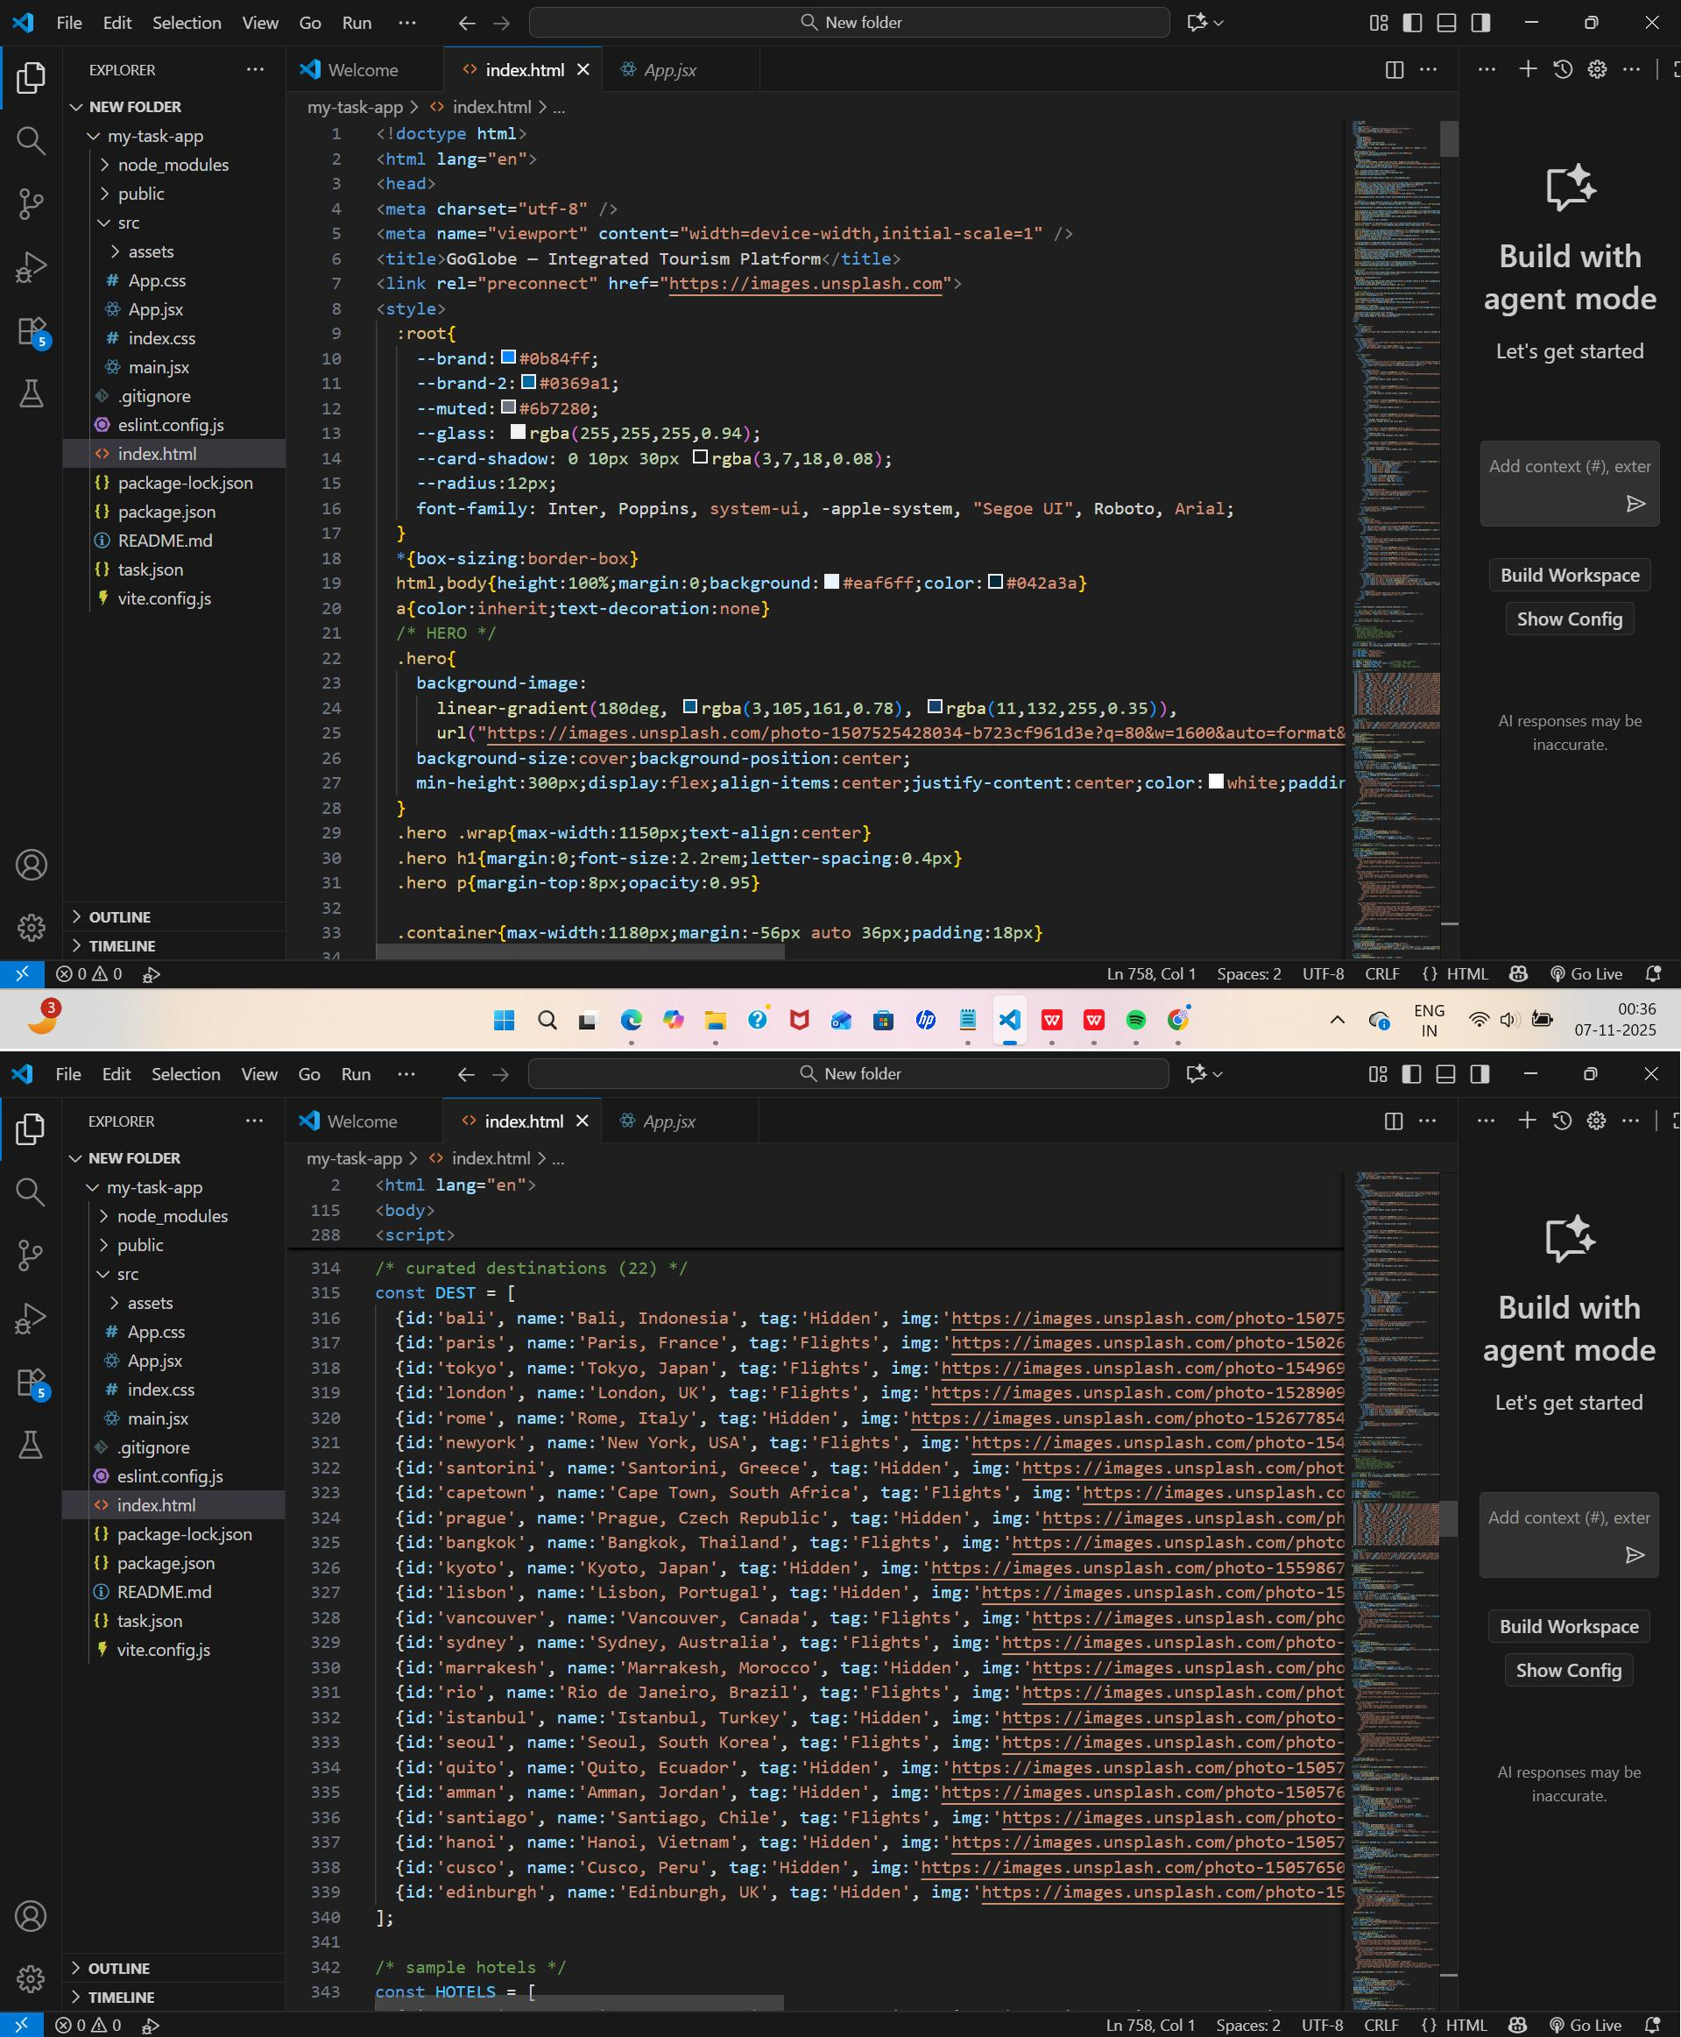
Sample code snippets
Installation/setup instructions

The GOglobe Integrated Tourism Platform is simple to install because it is built entirely using HTML, CSS, and JavaScript. It does not require any external frameworks or databases. The setup can be completed in just a few steps.

First, download or copy the complete GOglobe project folder to your local computer. If it is shared as a ZIP file, extract it using any standard extraction tool. Make sure all files especially index.html, style.css, and script.js (if included) are in the same folder.

Next, open the folder in a text editor like Visual Studio Code or Sublime Text to review or modify the code. To run the project, simply double-click on the index.html file or right-click and select “Open with Browser.” The website will open and function in any modern browser such as Google Chrome, Microsoft Edge, or Firefox.

No installations or dependencies are needed. The project is fully self-contained and works offline, making it ideal for classroom demonstrations and educational submissions.

User manual or guide

When you open the GOglobe platform, the homepage displays the main navigation bar with options like Login, Register, Destinations, and Travel Assistance. Users can begin by clicking the Login or Register buttons. A clean, half-page form will appear where users can enter their details to simulate login or registration.

Once logged in, users can explore Top Global Destinations, view beautiful travel images, and get information about each place. The Travel Assistance section offers quick options like medical help, hotel booking, and transportation support all designed for educational simulation.

Navigation through the platform is smooth, with buttons that automatically scroll to their respective sections. Alerts confirm actions such as successful login or registration. The entire experience demonstrates how an integrated tourism platform would look and behave in a real-world environment.

Geo Tag photos with guide
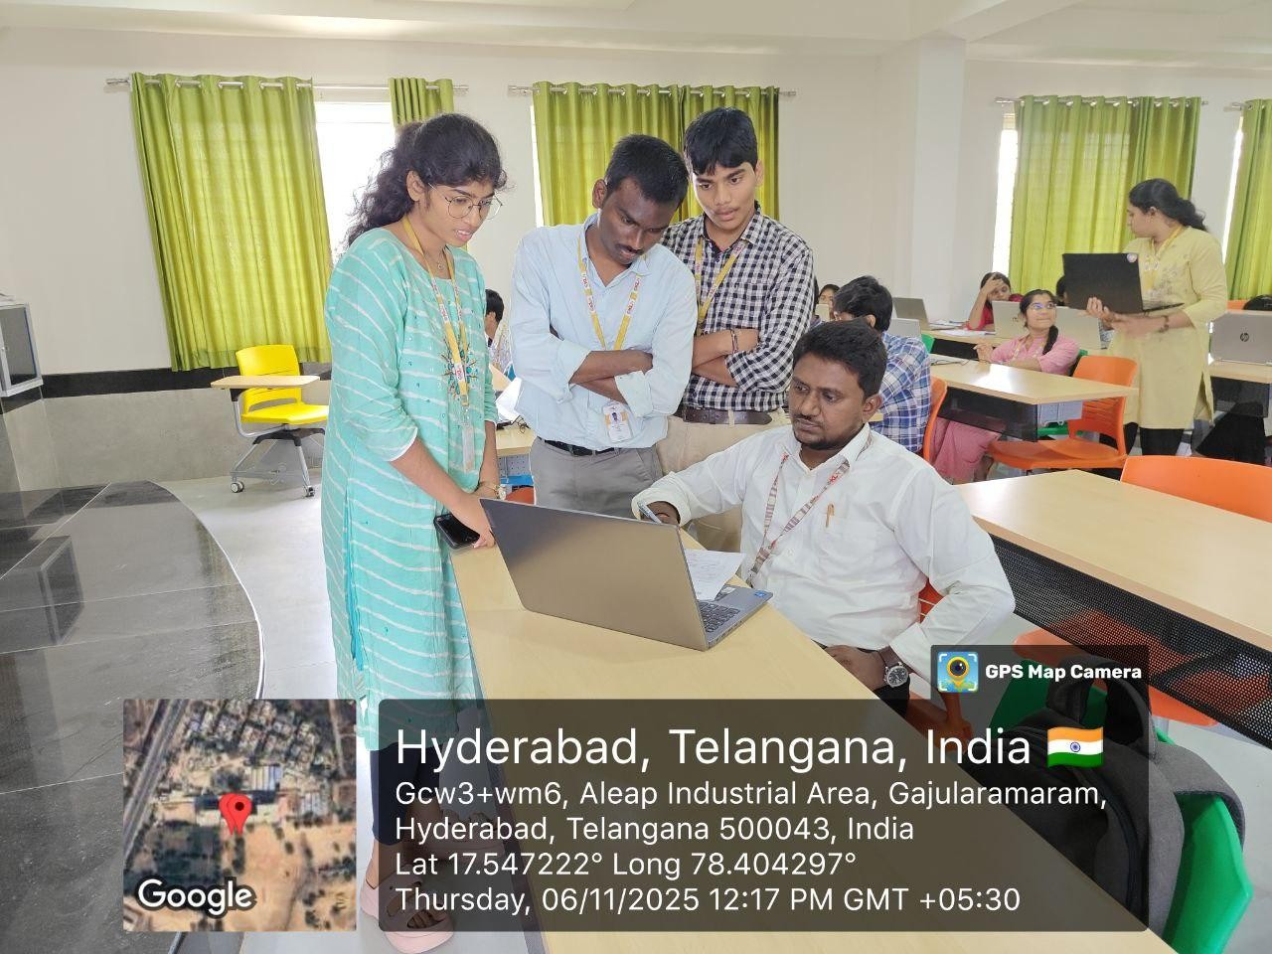

Review forms with guide signatures

